**EX NO 4 BFS AND DFS**

**Team Ai 4 life**

Aayushi Goenka (RA1911031010151)

Kapuluru Srinivasulu (RA1911031010142)

Sonia Raja (RA1911031010152)

Sadekar Adesh (RA1911031010141)

Praneet Botke (RA1911031010149)

Sai Mohit Ambekar (RA1911031010137)

**Title:**

Implementation and Analysis of DFS and BFS for an application

**Problem Description:**

A web crawler bot is like something to search the World Wide Web automatically for Web indexing. The problem here is to show how the DFS and BFS traverse through a simple web page.

**Solution:**   
The idea is to start from source page and follow all links from source and keep doing same using DFS and BFS.

**Python Code using BFS:**

from time import time

graph = {

'Homepage': ['AboutAuthor', 'RecipesIndex'],

'AboutAuthor': ['Summary', 'Contact'],

'Summary': [],

'Contact': [],

'RecipesIndex': ['Veg'],

'Veg': ['BreakfastIndex', 'LunchIndex', 'DinnerIndex'],

'BreakfastIndex': ['Idli', 'Dosa'],

'LunchIndex': ['RiceVariety', 'sambar', 'Curd'],

'DinnerIndex': ['Chappathi', 'Naan', 'Phulka', 'AlooMutterMasala'],

'Idli': [],

'Dosa': [],

'RiceVariety': [],

'sambar': [],

'Curd': [],

'Chappathi': [],

'Naan': [],

'Phulka': [],

'AlooMutterMasala': []

}

visited = [] # List to keep track of visited nodes.

queue = [] # Initialize a queue

def bfs(visited, graph, node):

visited.append(node)

queue.append(node)

while queue:

s = queue.pop(0)

print(s, end="\n")

for neighbour in graph[s]:

if neighbour not in visited:

visited.append(neighbour)

queue.append(neighbour)

# Driver Code

t0 = time()

bfs(visited, graph, 'Homepage')

t1 = time() - t0

print('Time for BFS :', t1, 'seconds')

**Output for BFS:**

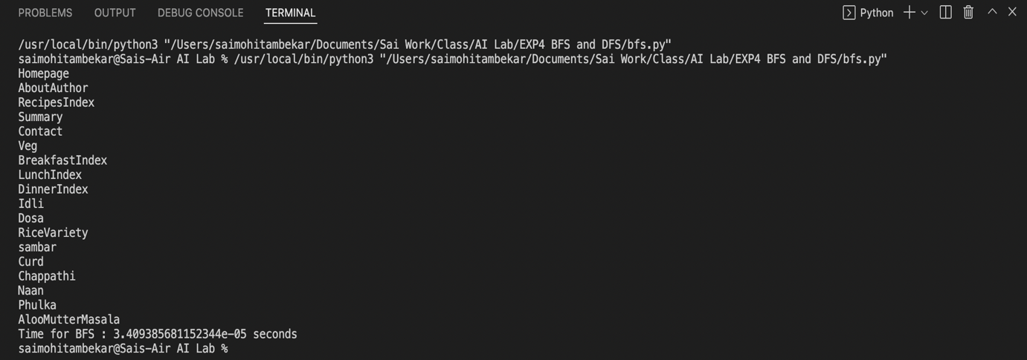

**Python Code using DFS:**

from time import time

graph = {

'Homepage': ['AboutAuthor', 'RecipesIndex'],

'AboutAuthor': ['Summary', 'Contact'],

'Summary': [],

'Contact': [],

'RecipesIndex': ['Veg'],

'Veg': ['BreakfastIndex', 'LunchIndex', 'DinnerIndex'],

'BreakfastIndex': ['Idli', 'Dosa'],

'LunchIndex': ['RiceVariety', 'sambar', 'Curd'],

'DinnerIndex': ['Chappathi', 'Naan', 'Phulka', 'AlooMutterMasala'],

'Idli': [],

'Dosa': [],

'RiceVariety': [],

'sambar': [],

'Curd': [],

'Chappathi': [],

'Naan': [],

'Phulka': [],

'AlooMutterMasala': []

}

visited = set() # Set to keep track of visited nodes.

def dfs(visited, graph, node):

if node not in visited:

print(node)

visited.add(node)

for neighbour in graph[node]:

dfs(visited, graph, neighbour)

# Driver Code

t0 = time()

dfs(visited, graph, 'Homepage')

t1 = time() - t0

print('Time for DFS :', t1, 'seconds')

**Output for DFS:**

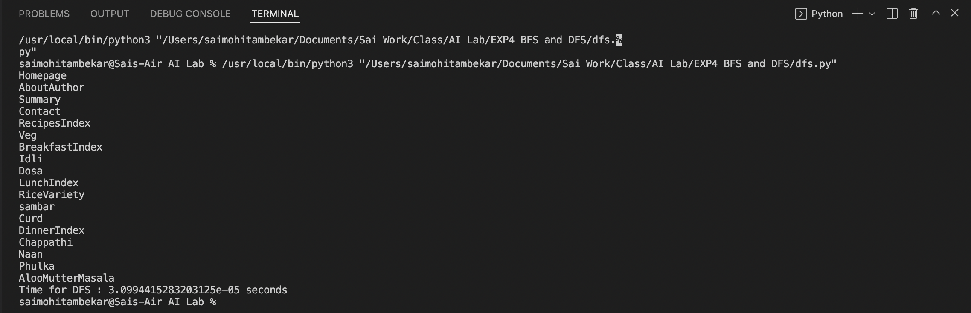

**Analysis:**

The time complexity for DFS and BFS on a graph is O(V + E); where V is the number of vertices and E is the number of edges. From the output, it is clear that time taken to traverse the nodes using **DFS (0.0019secs)** is better than **BFS (0.0026secs).**